Method Parameters

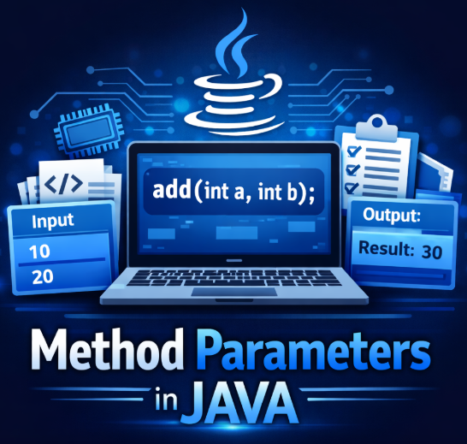

Method Parameters
Definition:
Method parameters are the variables declared in a method definition that receive values (arguments) when the method is called, allowing the method to work on that data.

In Simple Words
Parameters = input variables of a method They help the method accept data from outside.

1.What Exactly happens when you pass parameters?
When you call a method:-
add(10, 20);
Java does 3 steps internally:
- Create new variables (parameters) in memory
- Copy values of arguments into those variables
- Execute method using those copies

Example
void add(int a, int b) {
a = a + 10;
b = b + 20;
}
int x = 5;
int y = 10;
add(x, y);
Internally:
a = 5 (copy of x)
b = 10 (copy of y)
Original x and y stay Two Main Memory Areas in Java
2. Memory Level Understanding
Two Main Memory Areas in Java :-
When your program runs, memory is divided into:
1. Stack Memory
- Stores:
  - Method calls
  - Parameters
  - Local variables
- Works like a stack (LIFO)
- Very fast ⚡

2. Heap Memory
- Stores:
  - Objects
- Shared across methods

Flow of Method Call :
Let’s take this example:
class Demo {
void add(int a, int b) {
int sum = a + b;
System.out.println(sum);
}
public static void main(String[] args) {
int x = 10;
int y = 20;
Demo d = new Demo();
d.add(x, y);
}
}

Step-by-Step Memory Execution
Step 1: Main Method Starts
Stack:
main()
x = 10
y = 20
d → reference
Heap:
Demo object created

Step 2: Method Call Happens
d.add(x, y);
New stack frame is created

Step 3: Parameters Created
Stack:
add()
a = 10 (copy of x)
b = 20 (copy of y)
sum = 30
IMPORTANT:
- a and b are copies
- Not original variables

Step 4: Method Ends
add() stack frame is removed
Stack becomes:
main()
x = 10
y = 20
a, b, sum → destroyed ❌

5.Method Parameter Rules in Java
These are the rules Java follows when you define and pass parameters in methods.

1. Number of Parameters Must Match
Method definition and method call must have the same number of values
Correct
void add(int a, int b) { }
add(10, 20);
Wrong
add(10); // less arguments
add(10, 20, 30); // more arguments

2.Data Type Must Match
Argument type must match parameter type
Correct
void show(int a) { }
show(10);
Wrong
show("Hello"); // String ≠ int

3. Order of Parameters Matters
Java matches values based on position
void display(String name, int age)
Correct
display("Omii", 21);
Wrong
display(21, "Omii"); // order wrong
4. Variable Names Can Be Anything
Parameter names don’t need to match argument names
void test(int x)
int a = 10;
test(a);
x and a are different but it works

5. Parameters Are Local Variables
Parameters exist only inside method
void show(int x) {
System.out.println(x);
}
x cannot be used outside method

6. No Duplicate Parameter Names
void test(int a, int a) ERROR
Each parameter must have unique name

7. Final Parameters Rule
void test(final int x) {
// x = 20; not allowed
}
You cannot change value of final parameter

8. Type Conversion
void test(double x)
test(10); // int → double (allowed)
Smaller → bigger type allowed

9. Varargs Rule
void show(int... nums)
Rules:
- Only one varargs allowed
- Must be last parameter
Correct
void test(int a, int... b)
Wrong
void test(int... a, int b)

10. Method Overloading Depends on Parameters
Java differentiates methods using parameters
void add(int a, int b)
void add(int a)
void add(double a, double b)
Based on:
- Number
- Type
- Order

11. Default Values Not Allowed
Java does NOT support default parameters like some languages
void test(int a = 10) ERROR

12. Parameters Must Have Data Type
void test(a, b) ERROR
Must specify type:
void test(int a, int b)
6. Parameter vs Local Variables :
Feature | Parameter | Local Variable
Where declared | Method signature | Inside method body
Purpose | Receive input | Store temporary data
Value source | From method call | Assigned inside method
Scope | Inside method | Inside method
Memory | Stack | Stack

Example
class Demo {
void test(int x) { // parameter
int y = 20; // local variable
System.out.println(x + y);
}
}
Here:
- x → parameter (comes from outside)
- y → local (created inside)

9. Varargs Rule :-

What is Varargs?
Varargs allows a method to accept a variable number of arguments (inputs).
Instead of writing multiple methods, you can use one flexible method.

Syntax
void methodName(int... nums) {
// nums acts like an array
}
int... nums = Varargs parameter

Example (Basic)
class Demo {
void add(int... numbers) {
int sum = 0;
for (int n : numbers) {
sum += n;
}
System.out.println(sum);
}
public static void main(String[] args) {
Demo d = new Demo();
d.add(10, 20); // 2 arguments
d.add(1, 2, 3, 4); // 4 arguments
d.add(); // 0 arguments
}
}

